Exhibitor Registration Form 2020
Key Highlights of Exhibitions for Previous year
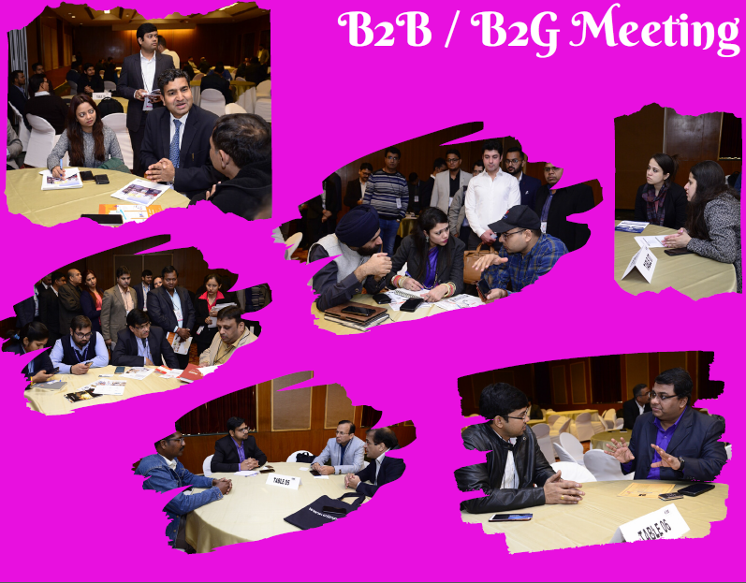

EXHIBITION REGISTRATION FORM

CII Member |  |  |  | Non-CII Member
CII Membership No |  |  | : | _________________________________
(Please quote this number to get the benefits offered to CII Members)
Organization |  |  | : | _________________________________
Mailing Address |  |  | : | _________________________________
City | : | ___________________ | Pin |  | : | ___________________
State | : | ___________________ | Country |  | : | ___________________
Mobile | : | ___________________ | Fax |  | : | ___________________
Email |  |  | : | _________________________________
GST Registration Number |  |  | : | _________________________________
Company PAN Number |  |  | : | _________________________________
Contact Executive for Exhibition Coordination (Name/Designation/Mobile/Email) |  |  | : | _________________________________

Name for Exhibitor Passes (with every booth of 6sqm: 02 and 9sqm: 03 complimentary exhibitor passes will be given):
S. No. | Name | Designation | Mobile | Email
1
2
3
4

Enclosed please find attached DD/Cheque No. ______________ Dated: __________ Amount: ______________ drawn in favor of “Confederation of Indian Industry” Payable at New Delhi towards our participation fee.
For Online Payment –
In case you are releasing the payment through RTGS / Online, Please use the following bank details -
- Account Holder Name – CONFEDERATION OF INDIAN INDUSTRY
- Bank name and address – STANDARD CHARTERED BANK, 23 Barakhamba Road, Narain Manzil, New Delhi – 110001
- Bank Account Number – 522-0-503577-5
- Type of Account – Current Account
- IFSC/ NEFT Code: SCBL0036020
- MICR Code – 110036002
- PAN No – AAATC0188R
- Service Tax No – AAATC0188RST004
- GST Number - 07AAATC0188R1ZB
Please mention Invoice Number and Event name in “PAYMENT REMARKS” while paying through NEFT/ RTGS. Kindly make one payment for one Invoice.
In Case withholding tax is deducted by you, please mention gross amount, TDS deducted and your TAN No, in Payment advice. Also issue us from 16A to claim credit for the same.
Mailing Address –
Mr Lokesh Kumar
ICT Team
Confederation of Indian Industry
249-F, Sector 18, Udyog Vihar, Phase IV
Gurgaon-122015, Haryana, India

Request you to kindly share the Online Track Number and Payment Advice Statement once Payment is done for Easy Settlement
Advance payment of the booth rent is mandatory to confirm your booking

Exhibitor Information (To be printed on the Exhibitor Catalogue)

Facia Name of the Booth *  (not more than 25 characters) | :
Company Name *  (To be printed on the catalogue) | :
Company Address * | :
City & PIN * | :
State & Country * | :
Mobile/Phone * | :
Fax * | :
Email * | :
Website * | :
Chief Executive *  (Full Name, Designation, Email) | :
Contact Executive for Exhibition Coordination *(Name/Designation/Mobile/Email) | :
Stall Number * | :
Stall Dimension (2*2), (3*2 ) , (3*3) , (4*3) , (5*3) * | :
Company Profile (100 Words)
Product Manufactured/Services Offered (100 Words)
Product on Display (100 Words)

Participation Fee and Terms of Participation
Last Date of Registration | : | 27 November 2020
Booth Fee | : | - INR 9,000/- per Sqm for CII member companies  - INR 10,000/- per Sqm for CII non-member companies  - Special Discount for MSME and Start up..  Note: Service Tax/GST as applicable would be extra as per rates prevailing at the time of raising the invoice
Mode of Payment | : | The payment could be made through Cheque/DD drawn in favor of “Confederation of Indian Industry” payable at New Delhi  Advance payment of the booth rent is mandatory to confirm your booking / Participation
Terms of Participation | : | - Space application will be on first come first basis  - Pre-registration is must due to security reasons  - Exhibition Fee once paid is not refundable  - With every booth of 2Sqm: 02 6sqm: 03 and 9sqm: 05  12Sqm: 06, 15Sqm: 08 complimentary exhibitor passes will be provided  - For any additional exhibitor pass, a fee of INR 5,000/- per pass will be charged  - If you have not received an acknowledgement before the Conclave, Please call us to confirm your booking  - Participation of foreign national would be subject to approval from the competent authorities  - No general visitor invitation from exhibitor side is allowed  - CII will provide fully Built-up Booth with Facia Name, 01 Table, 01 Chair, Light, 01 Dustbin, Carpet and Power Point. Any additional requirement by the exhibitor will be chargeable  - Advance payment of the booth rent is mandatory to confirm your booking  - It is mandatory for foreign national to submit their ‘Security Clearance Form’ Latest by 22nd November 2018

Sample Design and Facilities of stalls:

- Stall Dimension (2*2) –

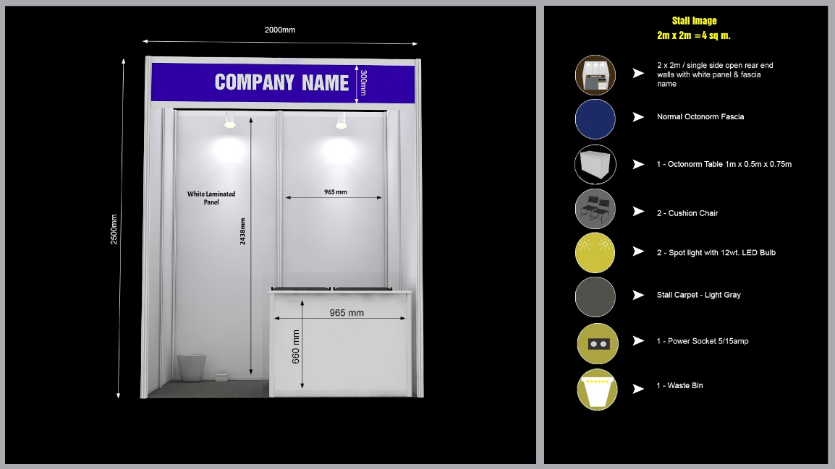

- Stall Dimensions (3*2) –

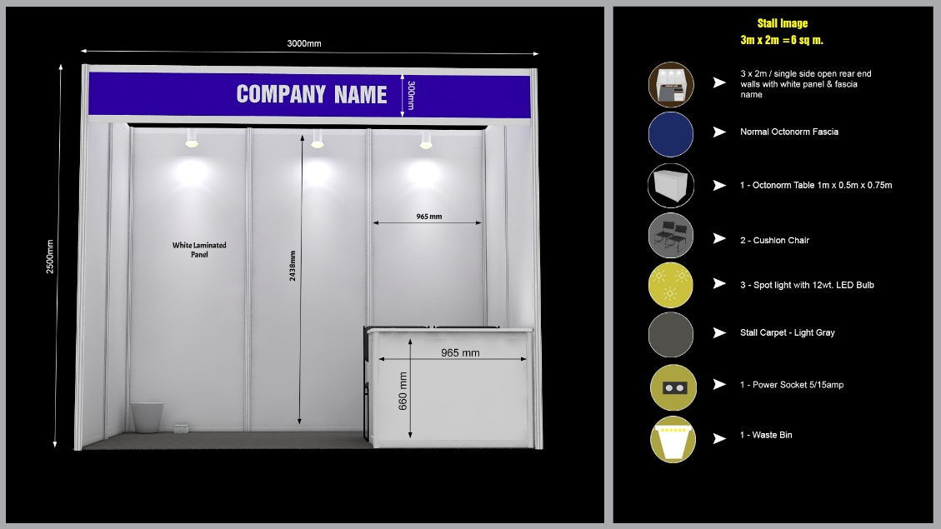
- Stall Dimensions (3*3) –
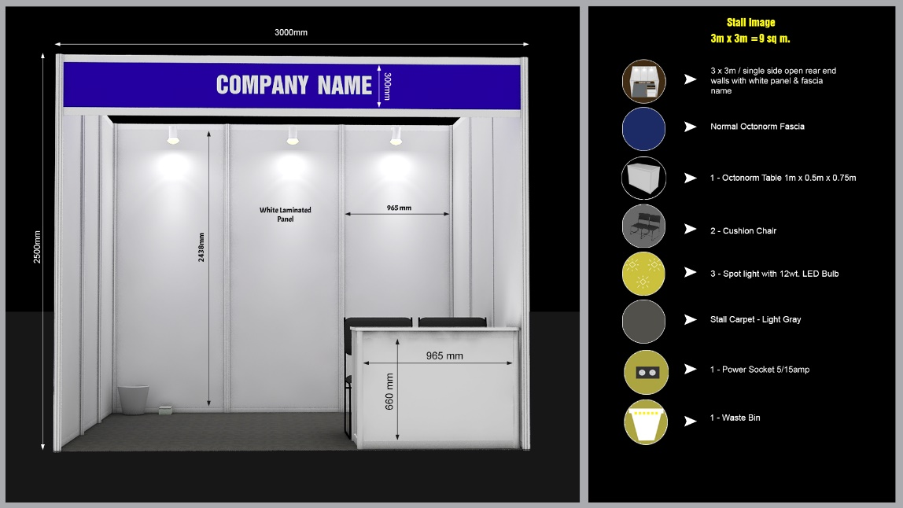

- Stall Dimension (4*3) –
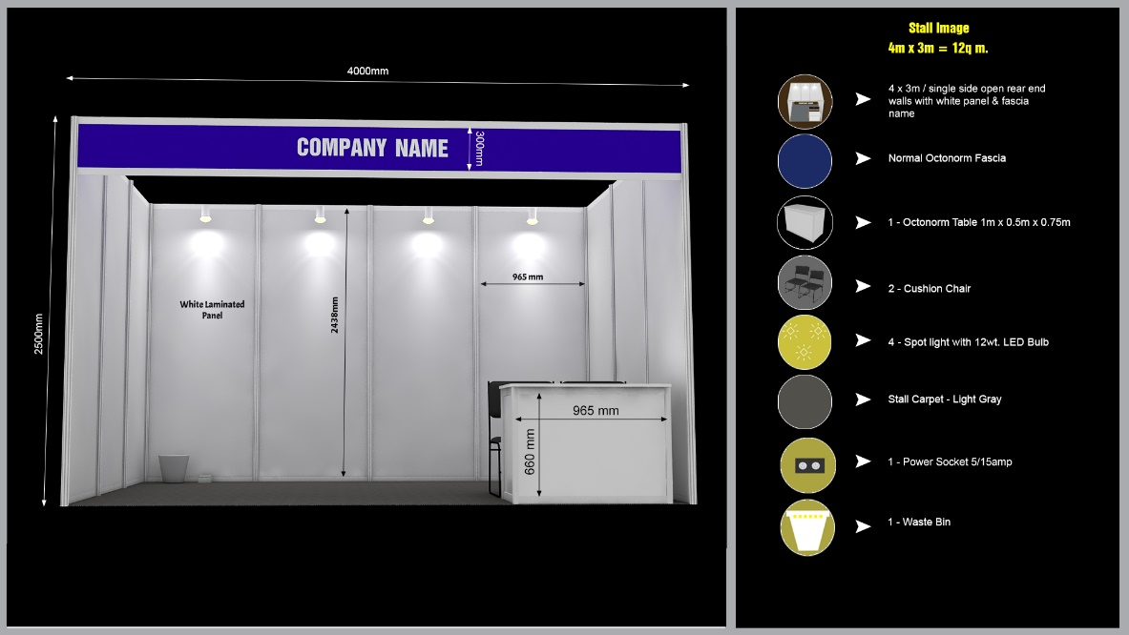

- Stall Dimension (5*3) –
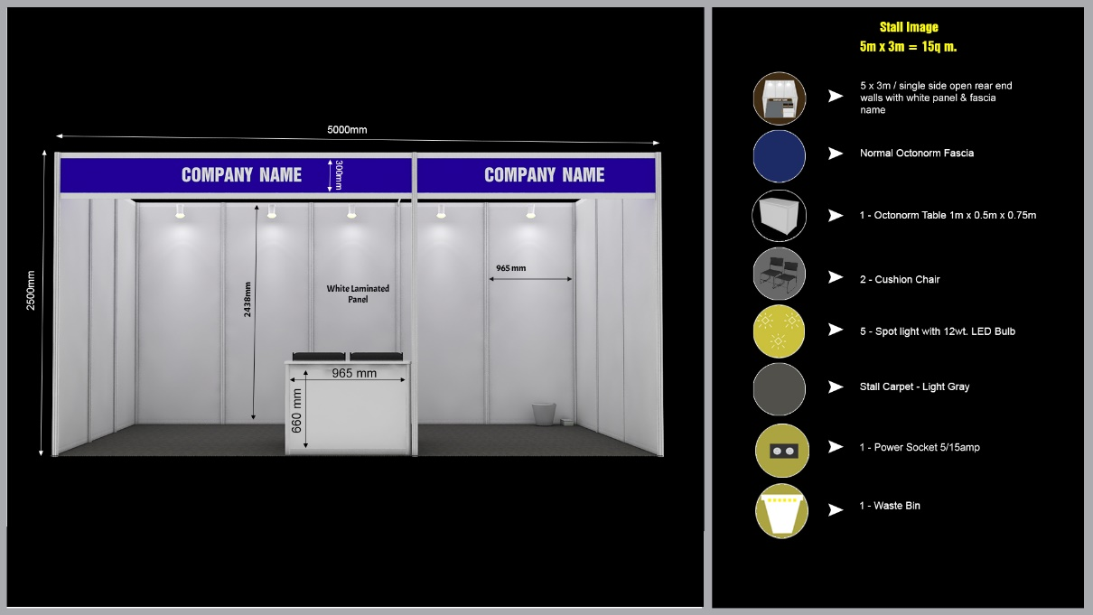

Please Note:
Whatever the information provided by you will be printed into the Exhibitor Catalogue So Please provide / Fill the Complete and Accurate information into the Form.

